**CRYPT HUNT DOCUMENTATION**

1. Ques : “Carefully observe and write the answer”

Ans: Answer

1. Ques: That tattoo on your arm.

-.-. / --- / -. / --. / .-. / .- / - / ..- / .-.. / .- / - / .. / --- / -. / ...

Ans: John F Kennedy

1. Ques:

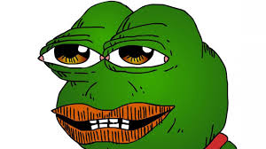

This picture will be there and an audio that says “Thanks”.

Ans: Osmgaming

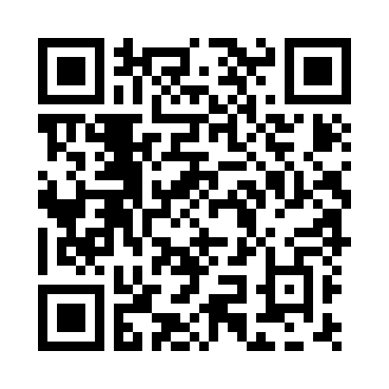

Ans: bees

1. ❑︎◆︎♋︎❒︎⧫︎♏︎❒︎ ◻︎♋︎⬧︎⧫︎

Ans: The fall of troy

1. 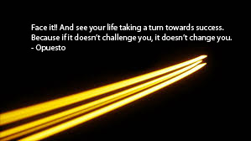

Ans : Couragueos.

1. 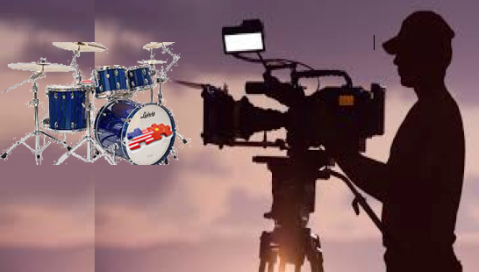

Ans : james wong howe

1. 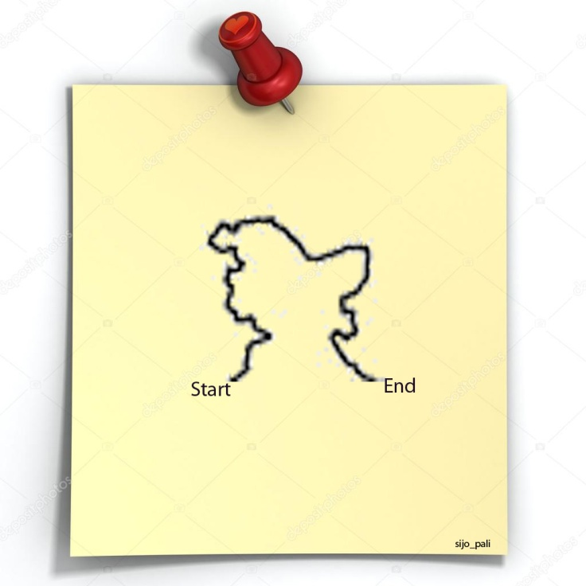

Ans: <https://instagurum.com/media/BYFzwvSnZBI>

1. "We must all try, in every way we can, to send the message that reading is critical to our lives and to the life of our nation."

Ans: George bush virus

1.  CLICK ME

When the user clicks click me she is directed to another page with the pic

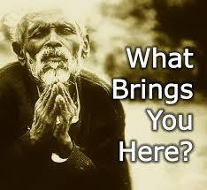

Ans: URL

1. The most difficult part of the conundrum was discovered.

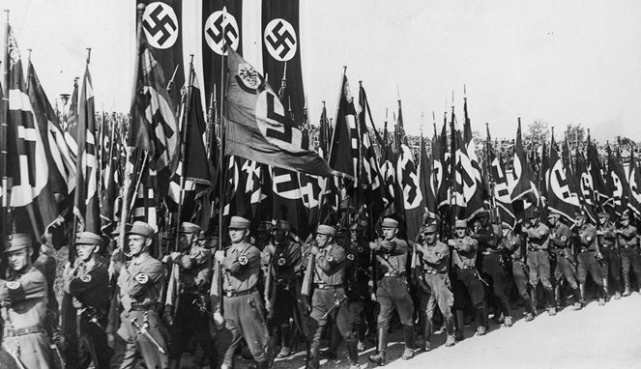

Ans: bletchley park

1. "The greatest enemy of knowledge is not ignorance, it is the illusion of knowledge"

Ans: george and the blue moon

1. 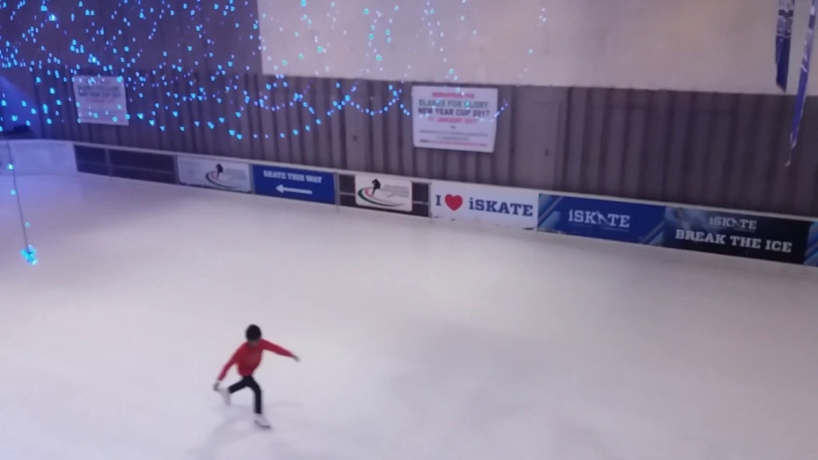

In the beginning…………….Was the command line

Ans: break the code.

1. 

Order for. Order from

Ans : Ofbusiness

1. 

Ans : IGDTUW

1. 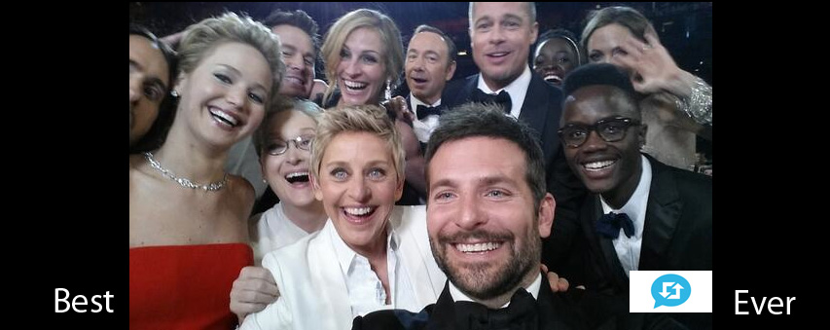

Ans: Bradley’s arm

1. Billions of breeds with sesame seeds.

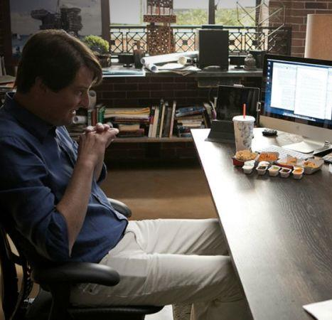

Ans : burger king

1. Ans : NIUE
2. 